what is yarn?
YARN is an Apache Hadoop technology and stands for Yet Another Resource Negotiator.YARN is a large-scale, distributed operating system for big data applications.
The technology is designed for cluster management and is one of the key features in the second generation of Hadoop,
the Apache Software Foundation’s open source distributed processing framework. YARN is a software rewrite that is capable of decoupling
MapReduce’s resource management and scheduling capabilities from the data processing component.

diff betw hadoop 1.x and 2.x
Hadoop 1.x supports only one namespace for managing HDFS filesystem whereas Hadoop 2.x supports multiple namespaces.
Hadoop 1.x supports one and only one programming model: MapReduce. Hadoop 2.x supports multiple programming models with YARN Component like MapReduce, Interative, Streaming, Graph, Spark, Storm etc.
Hadoop 1.x has lot of limitations in Scalability. Hadoop 2.x has overcome that limitation with new architecture.
Hadoop 2.x has Multi-tenancy Support, but Hadoop 1.x doesn’t.
Hadoop 1.x HDFS uses fixed-size Slots mechanism for storage purpose whereas Hadoop 2.x uses variable-sized Containers.
Hadoop 1.x supports maximum 4,000 nodes per cluster where Hadoop 2.x supports more than 10,000 nodes per cluster.

what is yarn architechter
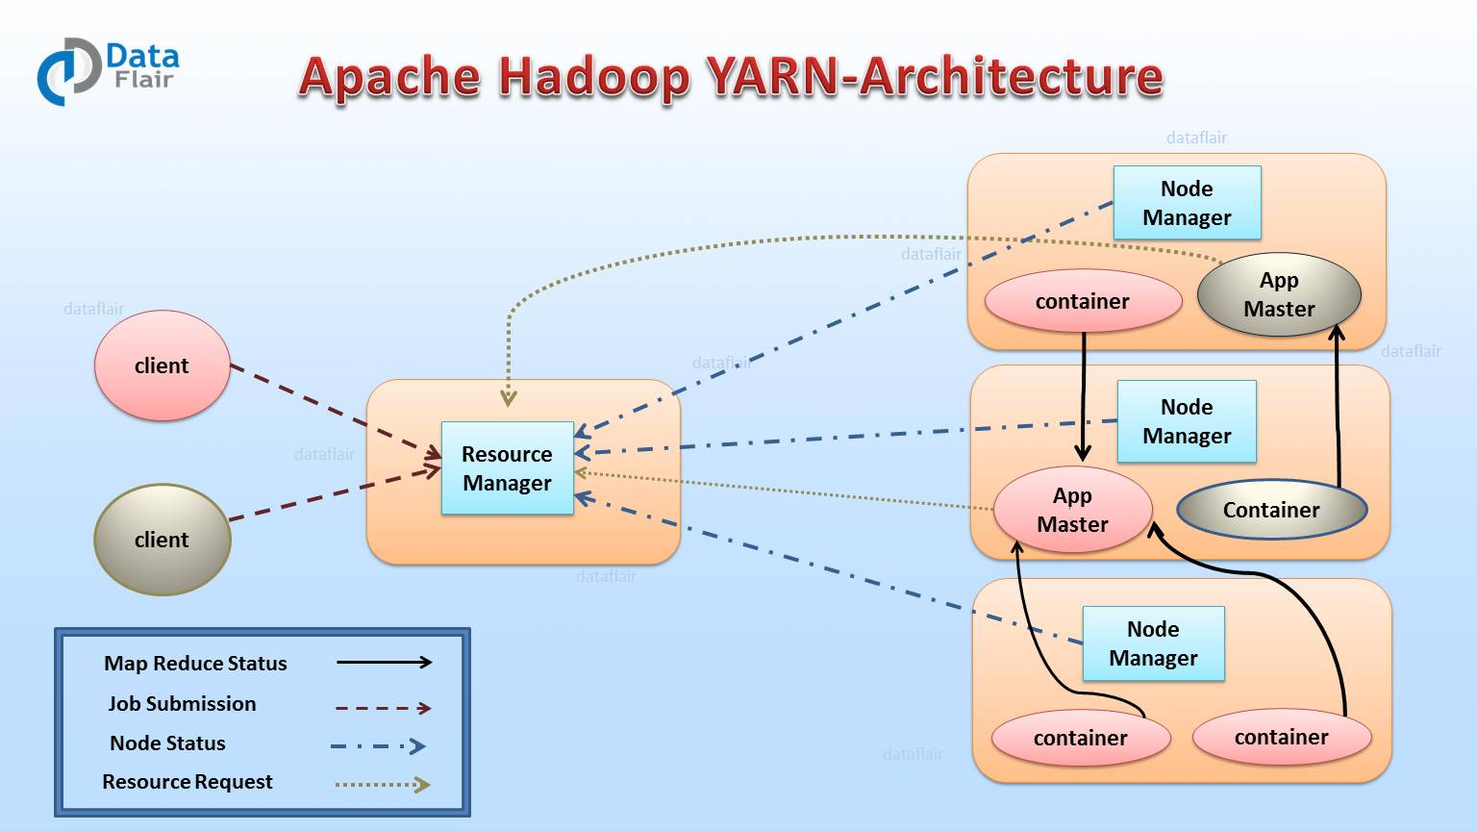

1. Resource Manager (RM)
It is the master daemon of Yarn. RM manages the global assignments of resources (CPU and memory) among all the applications. It arbitrates system resources between competing applications. follow Resource Manager guide to learn Yarn Resource manager in great detail.
Resource Manager has two Main components:
- Scheduler
- Application manager

a) Scheduler
The scheduler is responsible for allocating the resources to the running application. The scheduler is pure scheduler it means that it performs no monitoring no tracking for the application and even doesn’t guarantees about restarting failed tasks either due to application failure or hardware failures.

b) Application Manager
It manages running Application Masters in the cluster, i.e., it is responsible for starting application masters and for monitoring and restarting them on different nodes in case of failures.

2. Node Manager (NM)
It is the slave daemon of Yarn. NM is responsible for containers monitoring their resource usage and reporting the same to the ResourceManager. Manage the user process on that machine. Yarn NodeManager also tracks the health of the node on which it is running. The design also allows plugging long-running auxiliary services to the NM; these are application-specific services, specified as part of the configurations and loaded by the NM during startup. A shuffle is a typical auxiliary service by the NMs for MapReduce applications on YARN

3. Application Master (AM)
One application master runs per application. It negotiates resources from the resource manager and works with the node manager. It Manages the application life cycle.
The AM acquires containers from the RM’s Scheduler before contacting the corresponding NMs to start the application’s individual tasks.

how yarn is diffrent from hadoop1.x

